Social Investment Fund

Outcomes Agreement

Guide for Organisations

This guide provides information for organisations on how we will work together to establish an outcomes agreement and work together across the lifecycle of the agreement.



In this Guide
Topic | Page
1. About the agreement guidance | 3
Purpose of this guidance
Revisions
Feedback on the process
2. Overview of the end-to-end process | 4-7
Outcome-based commissioning overview
Relationship principles
End to end overview of the commissioning process
3. Establishment phase | 8-22
Agreeing ways of working
Agreeing the Theory of Change and Learning and Impact Plan
The IDI onboarding process
Refining the terms of the agreement
4. Learning and adapting phase | 23-36
Information sharing
Learning loops
Managing risk
Payments
Escalation process
Annual reflection
Feedback
5. Review phase | 37-39
Appendices | 39-42

Section 1: About this agreement guidance
Purpose of this guidance
This guidance is for organisations that have, or will soon have, a social outcome agreement with the Social Investment Fund (SIF). The social investment approach to working with organisations brings together, and builds on, good practice from government agencies and other organisations and sectors. As a result, our approach will feel different to some organisations, and will rely on different ways of working.
This guide provides a step-by-step overview, from setting up an agreement to how we will work together to build and maintain our partnership.
Revisions
This guide is a living document that will continue to evolve as we learn and grow. We are committed to improving the way we work based on feedback from the organisations we partner with. We may also need to make changes to align with updated policies or processes.
We’ll keep a record of any changes we make in future iterations, along with the reasons for those changes, in an appendix to enable you to see how we have learned and adapted over time.
To make sure you always have the most up-to-date version, please access this guide through our website (insert web link) rather than using a saved local copy of the PDF.
Feedback on this guidance
It is important to us to ensure that the information and guidance we are providing is clear and fit for purpose. If you have any feedback on the information and guidance provided either in this document or linked in it, please do let us know, either by:
- Letting your relationship lead know.

- Providing written feedback to us at info@sia.govt.nz.
Section 2: Overview of the end-to-end process
Outcomes-based commissioning overview
Outcomes-based agreements place importance on measuring progress towards mutually agreed outcomes rather than focusing on service delivery details.

Each outcome-based agreement underpins a medium-term learning partnership between the organisation delivering the initiative and the Social Investment Fund. While the organisation’s proposal and the Fund’s decision to invest are based on a shared confidence that the initiative will lead to improve outcomes, the ongoing partnership is focused on understanding whether outcomes are improving, how and why change is occurring; and whether the approach can be strengthened or scaled over time.
Outcomes-based commissioning for social investment requires:
High-trust relationships based on mutual respect
Greater focus on results, less focus on process
Longer-term agreements, allowing for learning
Funding for success

What is different in an outcomes-based agreement model?
At the Social Investment Agency, we want to work with you in a way that focuses on what really makes a difference in people’s lives. Outcomes-based agreements are different from traditional contracts because they shift the focus from what you do to what you help people to achieve. Here’s what that means for you:
1. We focus on outcomes - Instead of simply paying for the number of services delivered, we focus on the real impact of your work — whether people are achieving lasting positive change. This might be sustained employment, improved wellbeing, stable housing, or stronger family connections. Your creativity and expertise help the people you support to achieve outcomes.
2. Flexibility to shape delivery around what works - Outcomes-based agreements give you the freedom to tailor your approach to the people and communities you support, within your theory of change and evidence basis – rather than following a rigid prescription. This flexibility allows you to innovate, respond holistically, and meet and respond to people where they are.
3. Using data to drive reach and impact - We work with you to use data and evidence to understand reach and targeting, track progress, and measure success. This isn’t traditional ‘reporting’ — it’s a chance to learn what works, improve services, hear the voices of those you are working with, and show the real difference being made. Ongoing feedback helps everyone refine their approaches and achieve better outcomes across cohorts of focus over time.
4. Long-term focus - Outcomes-based agreements take a long-term view for the people being supported. We want to support early intervention, prevention, and lasting positive change — not just crisis management. We invest in outcomes over time, but our ongoing commitment does rely on those outcomes being demonstrated.
5. Simplifying and supporting providers through contract consolidation - Consolidating contracts previously held with multiple government agencies into a single outcomes-based agreement reduces administrative burden, can free you to focus on results, and allows your team to deliver services in the way that best suits your community.
Our learning approach – using data and evidence
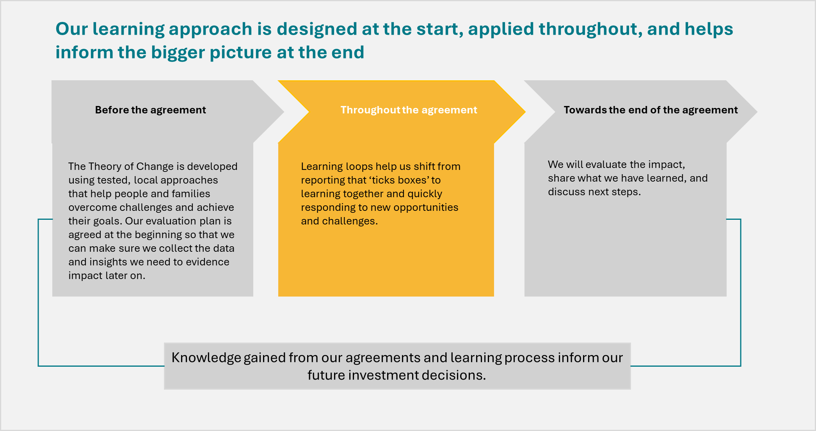

Relationship Principles
Our outcomes-based commissioning approach aims to support long term, transparent and mutually beneficial partnerships that enable each party to be open about their ambitions, risks, and challenges, while always keeping the focus on the purpose of our commissioning.
Our relationship principles (below) aim to support these partnerships and are aligned to our overall SIA values. Our social outcome agreements will include these principles and those of partner organisations.
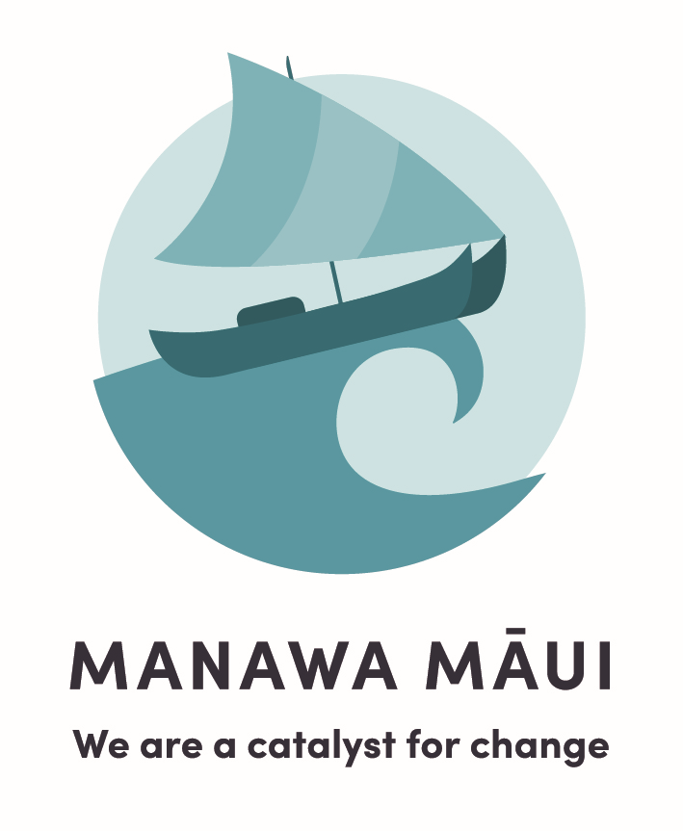

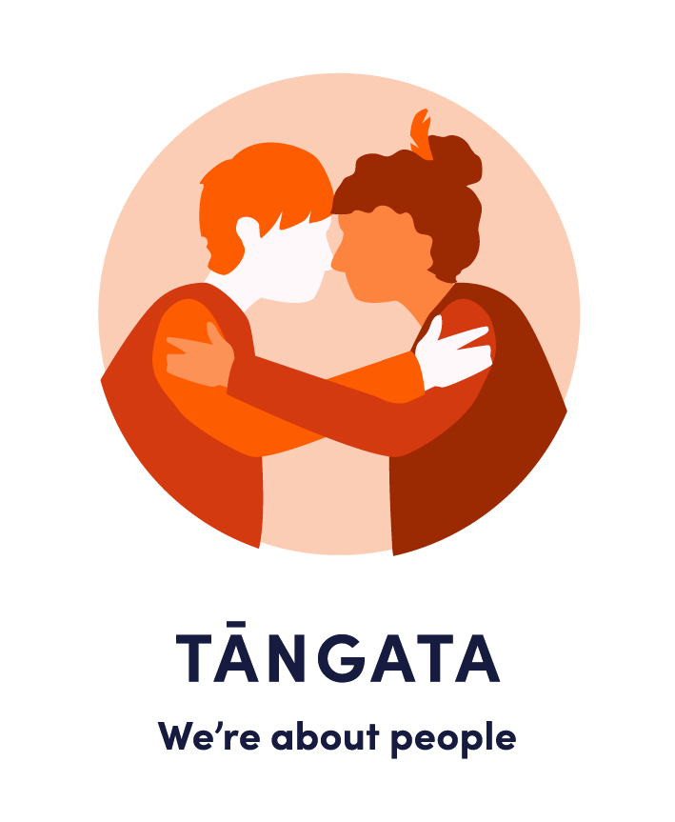
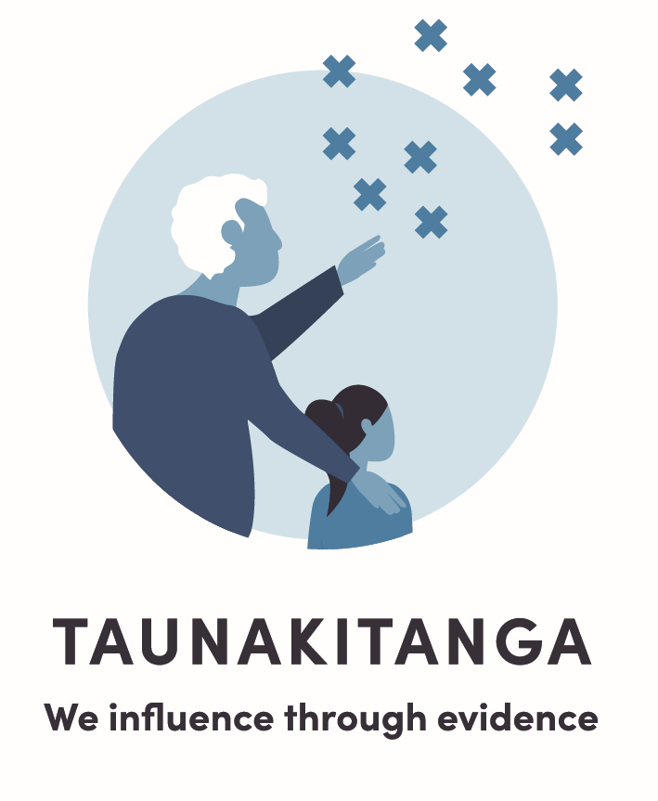
Values
Relationship principles
Trust & Respect: Build and maintain trust in each other through mutual respect and open and effective communication.
Shared accountability: Both parties are responsible for their own and joint outcomes.
Innovation & Continuous learning: Encourage diverse thinking and a culture of continuous improvement and ongoing learning, using insights to adapt, improve, and maximise the overall effectiveness and impact of what each of us do in relation to the agreement.
Transparency: make decisions and actions clear, avoiding surprises that materially affect how either of us operate for the purposes of the agreement or impact what we expect to get from the agreement.
Understanding & growth: Embrace challenges as opportunities for learning and growth, fostering a culture of understanding and support for each other.

Sustainable social sector development: Focus on enabling sustainable funding and service delivery that meets relevant population or local community needs and aspirations and recognises the value of Kaupapa Māori and community-led approaches.

Purposeful data collection and reporting: SIA will limit its data collection and reporting requirements to what is agreed to be necessary to support evaluation and learning and what is reasonable to support the discharge of the responsibilities it has to its own stakeholders.

Data equity: Enable appropriate access to relevant data and insights

End to end overview of the agreement process
The below process diagram provides an overview of the end-to-end agreement process. Subsequent areas of this guide will detail the activities you can see in this process in further detail.
Learning and Adapting Phase
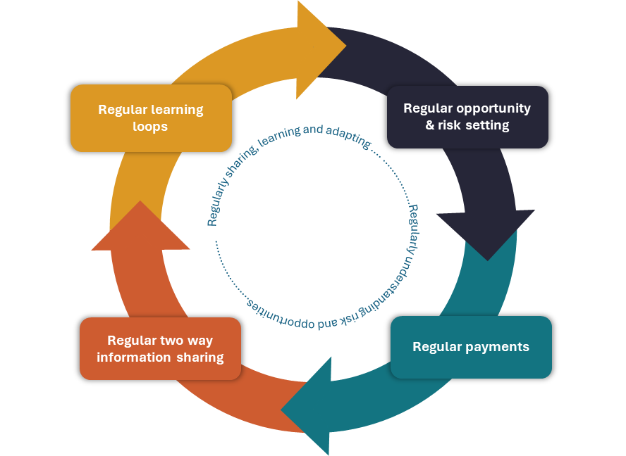
Review phase
Establishment phase

Relationship &
Ways of working
Impact analysis procCompleted
Terms of Agreement
Re-commissioning
Theory of Change &
Learning and Impact Plan
Data Sharing





Escalation process
Feedback process
As Required
Annual review process
De-commissioning

Section 3: Establishment phase
Once we have the decision to fund an initiative through the Social Investment Fund, there are several things we will have to work through together before we sign the agreement. We call this the establishment phase.
The first thing to clarify as part of the establishment phase is who the relationship leads are for either partner. The relationship leads will liaise regularly with each other and:
- Serve as the primary point of contact
- Support the resolution of any issues
- Ensure other colleagues are aware of where they are required during the process and what their responsibilities are
- Draft and negotiate terms of the agreement
- Coordinate any required regular information sharing requirements throughout the agreement
- Maintain visibility of the initiative
- Ensure compliance with the agreement and manage risk
- Manage documentation and records
- Schedule and lead key engagements including learning loop discussions, check-ins and annual reflections, coordinating and involving other colleagues within their organisation, as appropriate.
Other key people who might be involved in the agreement may also be identified at this stage. And of course, your organisation may establish a team who forms the core of your partnership with us.
The things we will need to work through together include:
- Agreeing our ways of working which includes establishing shared relationship principles and the outcome agreement relationship plan.
- Agreeing the Theory of Change and Learning and Impact Plan - how we will evaluate the initiative.
- Supporting you to work with Statistics New Zealand to share your data into the Integrated Data Infrastructure (IDI), through a Data Sharing Agreement (where applicable).
- Understanding what, if any, internal development you or we may need to undertake to field the capabilities our agreement will require.
- Agreeing on the terms of the agreement, which includes establishing the shared understanding of the opportunities of the investment and any risks, what information we will share with each other, how often we will engage with each other alongside other terms such as payment and accreditation.
The remainder of this section is broken down by the above four process areas.

Agreeing Ways of Working

Relationship Principles and Letter of intent
Working through all establishment phase processes may take some time, so one of the first things we will do is meet with you to outline the end-to-end process, establish our shared relationship principles, and share a letter of intent.
The relationship principles we commit to working to in all of our agreements are detailed at the beginning of this guide. You may also have some principles you would like us to collectively work to through our partnership. Together, these will set the tone for our agreed way of working with each other through the establishment, learning and adaptation, and review stages of the agreement.
We will share a letter of intent with you shortly after we notify you that your application has moved to final negotiation. This letter is a draft for discussion and can be adjusted if required. The letter will outline:
- An indicative date that we aim to complete negotiations
- Agreed relationship principles
- Items that will require completion during the establishment phase (i.e. the four establishment processes)
- The amount of funding that has been applied for over the life of the initiative
- Information sharing privacy statement
Outcome Agreement Relationship Plan
The next step will be to begin the co-development of a Relationship Management Plan, this will include:
- Administrative information (e.g. agreement name, term, expiry, annual agreement value)
- Relationship plan owners, including their name, role title and signature upon completion of the plan
- Summary of key events and activities including key times we will engage with others over the term of the agreement, including for learning loop engagements and annual reflection sessions.
- List of key people involved in the agreement and their role. This will include the relationship lead from each partner, the main contact for payments (if different from the relationship lead) and other key people.
Agreeing the Theory of Change and Learning and Impact Plan

With our ways of working established and letter of intent signed we will begin to work with you on confirming your Theory of Change (ToC) and developing a Learning and Impact Plan. Your SIA relationship lead will work with you on the best approach (e.g. working session/s, regular meetings, review processes).
For the New Investment pathway, you will have already provided a ToC as part of the application process. We may just need to agree on some of the finer details. For other pathways (e.g. Contract Consolidation), you might be working on the ToC during this establishment phase.
Overview of the Theory of Change
A Theory of Change (ToC) is a clear, shared understanding about how and why an initiative is expected to support people to achieve outcomes. It describes what we’re doing, with who and when, and why we think it will have real impact.
A ToC underpins the agreement we have with each other by defining the resource, activities, and measures that both parties believe will lead to change in outcomes. The ToC also becomes the foundation for our Learning Loop discussions (refer to Section Four below), where we use the ToC to discuss progress, understand what is or is not working, and decide how to adapt. More detailed support on developing your ToC can be found in the Quick Guide: Understanding Theory of Change and Logic Models.
The ToC will help define the outcomes and indicators or measures we track to understand whether the initiative is working as intended. Some outcomes will connect to the Government Outcomes the Fund seeks to achieve, while others may reflect results that are specific to your participants or community context. Measures may be drawn from multiple sources. Some can be tracked through the IDI data available in your organisation dashboards (refer to Section Three below), while others will be specific to your initiative and collected directly by you. Further guidance on outcomes and indicators can be found in the Quick Guide: Understanding How We Use Outcomes.
Social Investment Fund Outcomes
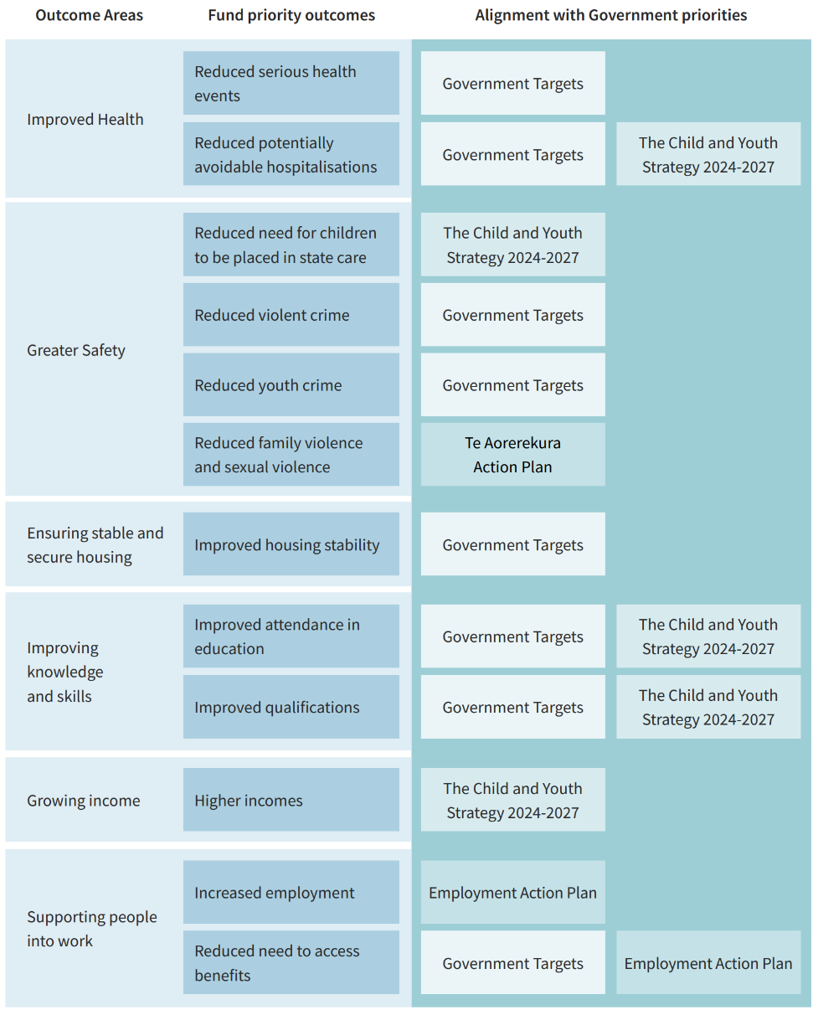

Agreeing the Learning and Impact Plan - how we will evaluate success
The Learning and Impact Plan helps us both understand whether the changes we observe are due to the initiative itself or for some other reason – not just that things have improved for the target group(s), but how and why. Although the impact analysis is completed toward the end of the investment, it is built from the start so that evaluation readiness, or “evaluability”, is established early. This ensures that data collection is purposeful, proportionate, and aligned with your Theory of Change.
These tools also help you monitor progress during the early stages of delivery so that any practical learnings can be incorporated as improvements (if any) to implementation.
Together, we will agree on an evaluation model and plan for each initiative, working with SIA’s evidence team or other evaluation experts as needed. This plan will define data sources, collection methods, and timing, and will embed evaluability into the design so we can estimate causal impact with minimal burden. The agreed approach will be documented in the final agreement.
A critical part of getting the impact analysis right is clearly defining the referral or eligibility criteria for participants. This allows us to accurately identify who is eligible, who participates, and who does not – an essential step for establishing credible comparison groups. If these referral pathway(s) or criteria change by mutual agreement during the initiative, the evaluation design may need to be revisited to maintain consistency and validity.
We will consider whether any ethics approval or waiver is required for data collection and evaluation activities. The responsible party leading the evaluation will obtain the necessary approval before data collection begins.
Impact analysis will typically rely in part on data provided to Statistics New Zealand’s Integrated Data Infrastructure (IDI). This data supports the evaluation and helps you understand more about the people you are reaching. Evaluation using IDI data including data linkage and technical assistance, is supported by SIA at no cost to organisations. This reflects our commitment to the social investment approach and to shared learning. Understanding outcomes benefits everyone – the Fund, the organisations delivering services, other government agencies, and most importantly, the communities being served.
Additional support on related topics can be found in the Quick Guides: Continuous learning and Data, learning and impact for the Social Investment Fund

The IDI onboarding process

To support the learning and impact plan and our learning loop conversations throughout the agreement, organisations we work with shares data for linking with the Stats NZ Integrated Data Infrastructure (IDI). The IDI is a large, legislatively protected, trusted research database that holds de-identified information about people and households in Aotearoa.
Before any data can be shared, a Data Sharing Agreement (DSA) will need to be agreed with Stats NZ, this agreement is subject to the discretion of the Government Statistician. The agreement is between Stats NZ and your organisation and is made independent of SIA.
Once the DSA is in place, your data can be brought into the IDI where it will be linked with other datasets relating to the cohort, de-identified (all identifying personal information removed), analysed and extracted, being made and available to both parties in confidential and aggregated formats.
The information that you will be asked to send to the IDI is set out in the following table.
Personal identifier(s) | Sufficient information for Statistics New Zealand to identify an individual, such as a unique identifier, for example NHI number, and/or name (s), gender, address, and date of birth. This data is used only by Statistics New Zealand for linking in the IDI and is not shared with the Social Investment Fund.
Initiative Name | Name of the initiative (if you are delivering more than one initiative funded by SIA).
Start date | The date the individual began working with your organisation.
Exit date | The date the individual ceased working with your organisation.

We are committed to sharing back:
- Insights about the individuals, whānau and families your initiative is reaching (aggregated into groups, not individuals) - such as what other supports they are receiving, their demographics, and life circumstances visible in government data.
- Insights about other individuals, whānau and families in the community your initiative is not yet reaching – helping your organisation understand who you might also reach.
- An estimate of the impact your initiative is having - how outcomes are changing for whānau, families and individuals participating in the initiative compared to similar groups who are not participants.
We’ll share this information on a regular basis through a dashboard created specifically for your initiative. For us to provide this dashboard, our data and analytics team will need to have a clear definition of your target participants (cohort(s)) to identify potential participants in the IDI. We will work with you on this, to ensure it is clearly articulated as part of the agreement.

We are also committed to learning what additional data from the IDI may be helpful to you in making sure you are reaching the people we have agreed you will be targeting with your services.

For further information on the how data is used for the outcomes agreement approach please refer to the following quick guide: Data, learning and impact for the Social Investment Fund.
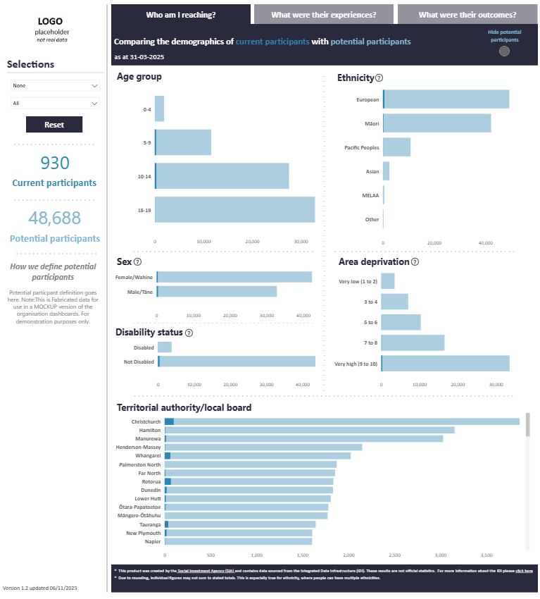
You can access an example dashboard by following this link:
https://app.powerbi.com/view?r=eyJrIjoiNjFiNDM4OWYtZDRlZC00ZjA5LWE5ZmQtNzdlOTgyNjU4N2JmIiwidCI6ImI2YTdiZWNkLTY2ZWEtNGIyNy1iOTIzLWYwZjY1MjdlMTk2YiJ9

This example uses fabricated data and is a mock-up ONLY for illustrative purposes.
For you to securely share data into the IDI on a regular basis, there are few things that we will support you to work on with Stats NZ, in preparation for data sharing. This includes a Data Standard (provided by SIA), a Data Sharing Agreement, a Confidentiality Agreement and completing a Data Specification.
Data Sharing Standard
The Social Investment Fund Core Data Sharing Standard is held by SIA and is the minimum information to be provided to Stats NZ.
Data Sharing Agreement
The Data Sharing Agreement describes the purpose of sharing data in the IDI and outlines the protections that Stats NZ has in place (along with any conditions agreed between you and Stats NZ).
Before Stats NZ enters into a Data Sharing Agreement with you, they will undertake an independent assessment (privacy impact assessment). This assessment will be to check that the personal information collected is appropriate to be shared and integrated in the IDI. Stats NZ use the information provided by you in the Data Sharing Specification to conduct this assessment. We can work with you to provide the necessary information for this, but it is at the discretion of Stats NZ to enter into this agreement with you. If they have any concerns, you may not be eligible to integrate your data into the IDI; however, we will provide support to work through any concerns they may have, if required.
Confidentiality Agreement
Stats NZ will also provide you with a Confidentiality Agreement to sign. This agreement states that you give SIA permission to identify your organisation in the data loaded in the IDI. This will allow SIA to create your organisation dashboard. If any researcher outside of SIA wish to use the data supplied by your organisation, they will need to request this from Stats NZ who will seek your permission before granting access.
Data Specification
The Data Specification has all of the technical information about the data that will be sent to Stats NZ. Stats NZ will help you document this in the specification, and this will include key practical information like the frequency of data supply and what data specifically will be sent. Refer to the Data Sharing Primer for more information.
You will also need to update your privacy statements to ensure people participating in your initiative know you are sharing information in the IDI.
Stats NZ currently has a secure data transfer service that you will be set up with a login for. This service is fully accredited to ensure that it is safe and secure. They will test that with you to make sure you can upload data and that they can receive it. We will provide support to you throughout this process.
Refining the terms of the agreement

Once we have a clear understanding of the Theory of Change and the IDI onboarding process is underway, we will work through refining the terms of the agreement with you. This may take place over multiple discussions with different people required from both partners to inform each topic. As with the other process areas, your SIA relationship lead will work with you to establish any sessions and guide you through the process. The key areas that make up the terms of the agreement include:
- Understanding the opportunities and risk profile of our shared investment
- Agreeing the level of investment
- Social sector accreditation
- Information sharing requirements (separate from IDI requirements)
- Payment details
Based on this information, we (SIA) will produce a draft agreement for your review prior to commencing the sign-off process.
Understanding the opportunity and risk profile of our shared investment
As a central agency, SIA is accountable to several stakeholders, including the public, other Central Agencies (e.g. Treasury), auditors and Ministers. In order to provide certainty and assurance to those stakeholders that we can continue to credibly invest in social initiatives, it is imperative that we use a clearly documented approach to managing risk. We must demonstrate that we are assessing the opportunities and risks of funded initiatives and adjusting how we work with different organisations accordingly.
We are introducing a ‘shared opportunities and risk profile’ to use with our partners throughout our relationship. We recognise that where there are high risks there is sometimes the potential for high rewards or ‘opportunities’ to improve the lives of new Zealanders in new and innovative ways or with the hardest to reach people. We need to take a balanced approach across our social investment portfolio and communicate that with our stakeholders.
The shared opportunities and risk profile is a tool that will help us to:
- understand where we might need to monitor more closely or get into specific risks in more detail, and
- understand how often we should share information and engage with each other (learning loop sessions). This shared assessment recognises that we have a medium-term learning partnership, where we both have a vested interest in the investment and its intended positive outcomes.
If the investment is considered to have higher opportunities and risk, we are likely to want to engage more regularly than a more conservative investment. The profile looks at opportunities and risk across six main domains and will support conversations over the course of the investment. Those six areas are:
- The level of investment per year – is it conservative or high value?
- The potential for sector learning – is the initiative strongly proven or is it more innovative?
- The people who will participate in the initiative – are they easy or hard to reach?
- Your organisations’ delivery experience – do you have a proven history of delivering similar initiatives in the proposed location, or are you proposing to deliver a new initiative or in a new location?
- The level of confidence in the outcomes being achieved in time to realise a return on investment – do we jointly have high or low confidence based on the information we are sharing?
- The level of political and/or reputational risk associated with the investment - is there a low or high political and reputational risk? This includes any risk of failure of the Crown to meet statutory obligations.
This level of risk across the six areas will be agreed during the establishment phase and will then be reviewed at each engagement (learning loop). This will enable us to understand how the profile of our shared investment is changing over time and how we might need to respond i.e., increase frequency of engagement, change the agreement, put in place additional mitigations, escalate, celebrate and share etc.
This shared tool also recognises that you too will have key stakeholders you are accountable to throughout the delivery of this investment. And, you will have your own ways of understanding opportunities and risk through the implementation and delivery stages of the initiative that you will be monitoring and sharing with your management and governance groups. Understanding some of this detail will be helpful for us in our learning loop conversations, particularly in areas where we have collectively identified there are higher opportunities and risks.

Shared Opportunity and Risk Tool
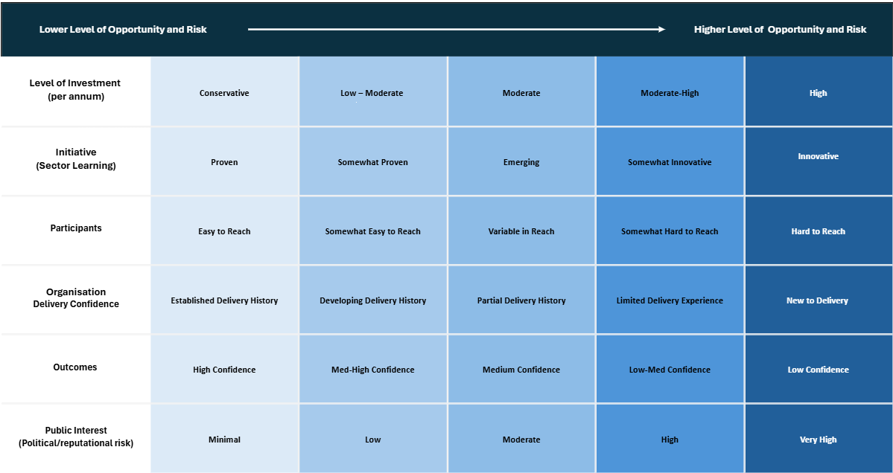
A version of this framework with full descriptors is included in Appendix A

Agreeing the level of investment
To agree the total investment over the term of the agreement, you will be asked to provide a proposed budget, outlining all anticipated costs associated with establishing and delivering your proposed initiative as outlined in the agreed Theory of Change/Logic Model. This may have been provided through an RFP, or we may request it through this establishment phase.
We encourage you to develop your budget in a format that works for you. If you would like additional support with developing a budget, your Relationship Lead can help.
Your budget should include provision for all costs associated with the initiative, including the following.
Set-up costs | These are one-off costs incurred while setting up a new initiative. Set-up costs may include staff recruitment, training to build capability, specific initiative training, infrastructure such as IT and security, equipment, licensing, etc.
Direct support costs | Direct support staff are all staff directly involved in delivering the initiative. This includes all practitioners and might also include team leaders or direct management support who are essential to the delivery of the initiative. General management and administration costs should be included in overhead costs (see below).
Other direct costs | This includes equipment, resources and other related expenditure incurred in the direct delivery of the initiative. For example, staff development and external supervision, cell phones for practitioners, travel if required as part of the initiative, materials and training resources, accommodation and utilities related to travel. These costs can sometimes be shared across multiple initiatives.  For any accommodation-based initiatives, property-related costs should also be considered.
Overhead costs | This includes all indirect service costs, or costs incurred as part of running the organisation that will contribute to the effective delivery of the initiative but are not part of delivering the initiative. For example, this would typically include a proportion of management and administration costs, HR, IT, office utilities, organisational and professional training.
Inflation Adjustment | Standard inflation adjustments across initiatives supported through the Fund will apply. These will be discussed with your relationship lead.

Once you have submitted your budget, we will review it to ensure that all likely costs have been accounted for and check for consistency relative to a range of benchmarks. We may request further information from you at this stage.
As part of agreement discussions, we should collectively consider the implications of entering into this agreement, including any decommissioning costs and timeframes. This discussion is to ensure that you (the delivery partner) are not unfairly penalised or taking on inequitable risk in the establishment of the initiative. Decommissioning considerations should recognise that there are reasonable stand down or closure costs for the delivery partner. These could include step down periods or exit provisions relating to leases, timeframes around redirecting support staff, and other costs for material items funded when the initiative was established. We will negotiate these arrangements according to the circumstances of each funded initiative and record the decisions in the Outcome Agreement.
Outcome Agreements include allowance for annual inflation adjustments up to a maximum of 2.25%.
Social Sector Accreditation
All organisations that we invest in through the Social Investment Fund will require the appropriate social service accreditation provided through Te Kāhui Kāhu (Te Kāhui Kāhu). The level of accreditation required depends on the nature of the initiative and the participants you will be working with. For example, working directly with children requires a higher level of accreditation than working only with adults. We will work with Te Kāhui Kāhu to determine what level of accreditation is required for your initiative and that will be documented as part of our outcome agreement.
If you do not already hold the level of accreditation required, we will work together to agree a plan for gaining the required accreditation. Generally, we will require you to gain accreditation at the required level no later than six months after signing the agreement.
Information Sharing Requirements
To help us both understand how things are going, we will regularly share information with each other. We will regularly share with you a partner insights dashboard specific to your organisation and initiative(s). Information that is included in this dashboard and an example is included above in the IDI Onboarding Process section.
We will require you to share some information with us. This will help us meet our obligations under the Public Finance Act 1989 as administers of public funding. We will discuss with you what this might need to include, but it is likely to be things like: summary information on how the initiative is being implemented and delivered, the number of participants, FTE recruited, how you are adhering to or amending your ToC, caseloads and measures specific to your initiative that you will be tracking.
We will agree what information you share with us during our agreement establishment phase. The types of information being shared may look different during the early stages of the agreement if the initiative is new and only just being established and implemented. For example, there will be very little information on the participants of the initiative in the IDI, so the partner insights dashboard may take some time to provide useful insights.
For agreements being established under the contract consolidation pathway there may be instances where reporting requirements from prior contracts are included in the new agreement. This will be determined on a case-by-case basis and will be agreed between us.
Payments
As part of our conversations about our regular sharing of information and frequency of engagements, we will also agree the frequency of payments made as part of the agreement. This will be dependent on some of those aspects of the agreement i.e. payment frequency will usually be aligned to the opportunity and risk profile of the investment (which includes the value of the investment) and the frequency of information sharing.
Payment frequency may look different for the implementation stage of the initiative compared to the ongoing delivery stage of the initiative depending on what works best for the specific circumstances. Generally, we will pay you in advance in quarterly payments. This is an example of what it could look like:
In this example, the variables in the implementation stage are largely varied, and the delivery partner prefers and/or is not financially compromised to be paid in arrears:
Stage of initiative | Frequency
Implementation Stage | Monthly in arrears
Delivery phase | Quarterly in advance
In this example, it is a conservative initiative where both partners are confident the implementation and delivery phases will go to plan.
Stage of initiative | Frequency
Implementation Stage | Monthly in advance
Delivery phase | Six-monthly in advance
From this information, we will draft an agreement for your review. You are encouraged to get advice, and you may request changes or clarification at this point. We will work together until we are both happy with the agreement. Once both parties are satisfied, the appropriate delegated authority will sign the agreement on behalf of each partner.
Section 4: Learning and Adapting Phase
With our agreement successfully established we will now enter the ‘Learning and Adapting’ phase together. This phase is a cycle of regular two-way information sharing, having learning loop discussions, understanding opportunities and risk and making payments. The frequency and the way that these activities will occur is agreed during the establishment phase.

Our online portal helps to support communication and collaboration throughout the learning and adapting phase. This is where we can both access information relating to your agreement, including scheduling sessions, summaries of discussions and share information with each other.
When your agreement is established, we’ll provide you with information on how to get setup in the portal and where to access support. We’ll also provide guidance material to support your navigation of the portal alongside information on how you can submit feedback to ensure we can continually improve the tool and ensure it is fit for purpose for our partnership.
The remainder of this section is broken down into the different activities that make up the ‘Learning and Adapting’ phase.
Information Sharing

As outlined in section 3 above, we will agree the information sharing requirements as part of establishing the agreement. We recognise most delivery partners will already be capturing and reporting this kind of information for their own internal purposes in operational, management or governance reporting. Therefore, we will not ask you to share information in any specific format but will jointly agree on how best that may occur for given circumstances. Some of this information may be shared verbally in our regular engagements and recorded by us in our shared commissioning portal.
The mutual sharing of information will help inform our learning loop conversations on what is working well, what we are learning, what might need to change and adapt, and what system barriers are getting in the way of achieving positive outcomes. This helps both of us have a shared understanding of our investment’s opportunities and risks and whether that has shifted or changed over time.
We will commit to sharing our information with you prior to our learning loop discussions so that you have time to analyse and review it, wherever possible. As we implement our processes to regularly share the partner insights dashboard with you, this may not always align – particularly in periods where we might be waiting for an IDI information update process (which currently happens three times a year). Over time, as the social investment approach becomes increasingly embedded, this should become more seamless.
The frequency of information sharing will be outlined in your outcome agreement. The ability for us to share information with each other, including updates to your partner insights dashboard, will be available through our commissioning portal. Our intention is to have our commissioning portal support the easy two way sharing of information.
Learning Loops

Learning loops are collaborative discussions where both partners sit down and discuss emerging evidence, trends and other insights from the information we have shared with each other. This activity helps us to come together to understand what is working, what isn’t, and how we pivot, if needed, to ensure we are continuously moving towards the outcomes that we are looking to achieve.
Learning loops support the social investment approach, which is about collaborating for learning, meaningful and trusted partnerships, using data to adapt and improve and, having a clear view of the impact the initiative is having on the people you are supporting, and any barriers that are getting in the way of outcomes.
For government, these discussions are essential for learning what works, shaping future investment decisions, and identifying system barriers that may hinder progress. By surfacing these barriers early, we can develop targeted solutions, share lessons across the system, and drive broader, lasting improvements.
What is the purpose of a learning loop discussion?
Learning loops are collaborative conversations at regular points throughout the agreement where partners reflect on shared data, emerging insights, and what we are learning together. They strengthen our shared understanding of what is working, what isn’t, where we may need to adapt to stay aligned with the outcomes we want to achieve and consider whether our shared investment opportunities and risk have shifted.
At the start of the agreement, we will have agreed a Theory of Change (ToC) based on available evidence and a set of assumptions. Learning loop discussions allow us to assess how that ToC is playing out in practice and help us track progress and understand what adjustments each partner may need to make to support success.
Understanding progress toward our short and medium-term outcomes, using our agreed indicators and measures, helps us understand the opportunities and risk in achieving our long-term outcomes. For us as the funding partner, this also supports accountability for public funds, giving us the confidence needed to justify payments and ensuring we meet audit requirements.
For government, these discussions provide important insights that can inform future investment decisions and help guide policy development. For example, we are keen to understand how public service design and delivery interacts with, and can influence, the effectiveness of social services.
We also recognise that not everything that would be useful to know about how to do the best work for the people we’re looking to help, is yet known. We are interested in building our shared knowledge in this space.
By identifying system barriers early, whether in policies, processes, or structures, we can develop targeted solutions, share lessons across the system, and support improvements that lead to stronger outcomes for communities.
What inputs do we need for the learning loop?
When we develop our agreement, we will agree what information we will regularly share with each other. This information will be shared before we meet for a learning loop discussion, with plenty of time for each of us to have considered it. It will also be helpful for both of us to have reviewed our opportunities and risk profile to see what might have changed.
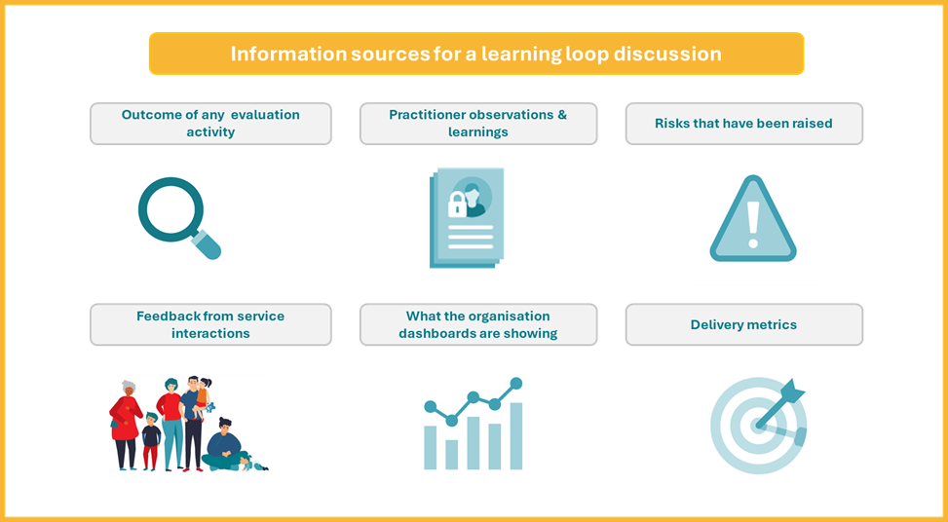
Who attends a learning loop discussion?
Learning loop discussions should, at a minimum, include both the relationship leads. The discussion may also include other key people; this could include leaders involved in the initiative delivery or other key subject matter experts, such as data and evaluation specialists. It is up to you to choose who will be a part of these discussions from your organisation. We will let you know ahead of time who we expect to be there from our organisation.
How are learning loop discussions carried out?
Ideally, learning loop discussions are held in person. This may not always be practical so sometimes they may happen via Microsoft Teams. Whether they are online or in person, we will record notes of the discussion and share these with you via our shared portal so that you can check they are an accurate reflection of our discussion and have a record for future reference.
Where do learning loop discussions happen?
If learning loops discussions are held face to face, you can tell us where you would like us to meet you. That could be at your head office, one of your local sites, at our office or somewhere else.
When do learning loop sessions happen?
We will have already discussed before we entered into our agreement how often we should have learning loop sessions. The most common frequency of learning loop discissions is likely to be quarterly.
Template Question Prompts to help prompt and record the discussion:
What is going well?
What are some of the key successes in the implementation and delivery phases of the initiative? How many participants are we reaching? Are the referral pathways working well?
Are there any unintended positive benefits being seen?
What is our collective evidence telling us about how we are tracking towards short and medium term outcomes?
What are we learning here that should inform future investments?

What is not going as we anticipated?
What are some of the key challenges in the implementation and delivery phases of the initiative?
Are there any unintended negative consequences?
What is getting in the way that we, as government, could do something about?
What is the shared evidence telling us about how we are tracking towards short- and medium-term outcomes?
What are we learning?
What is going on in the lives of the participants and potential participants of the initiative? What kinds of experiences have they had? Are their needs what we expected? Is the initiative able to meet their needs or are referrals to other agencies being made?
What government outcomes are being achieved (education, income, justice, housing etc.)?
How is support translating immediately into changes in people’s lives? What other changes are occurring (behaviours, skills, attitudes, feelings, aspirations…)? What barriers are getting in the way?
What needs to change?
What do we need to do differently? Does that have any impact on the agreed theory of change, learning and impact plan or referral criteria and pathways
Are there additional things we need to do to manage any opportunities or risks?
Are there any system barriers getting in the way of us achieving outcomes for participants as anticipated?
Sometimes broader system barriers can get in the way of things going exactly as we had planned.
What are some of the system barriers that are getting in the way that government could do something about?
What can the wider system learn from this?
Sometimes anonymised case studies can help demonstrate systemic barriers. We share these insights back with our central agency.
What have we agreed to do next as a result of this learning loop discussion?
Document the key points of what has been agreed as part of the discussion. This could include next steps and timeframes.
Some things we agree might result in a formal change to our agreement, theory of change etc. This may require more time to work through and additional discussions, with other key personnel.

Re-assessment of Opportunity and Risk Profile
Discuss and document how the opportunity and risk profile of the investment has change in light of the shared evidence learning loop discussion.
This may include discussing how we maximise opportunities and/or more detailed risk mitigation and. We will do this based on your organisation’s approach to understanding opportunities and risks.

Managing risk – opportunity and risk profile shared assessment
As investors of public money, we recognise the responsibilities and expectations that come with our role. The outcomes we collectively aim to achieve are often ambitious and complex, and we acknowledge that all partnerships, investments, and agreements carry a degree of risk.
We are committed to being open about both the opportunities and risks of our shared investment. This begins when the agreement is being shaped and continues throughout its duration, as we learn from new insights and adapt our approach. By talking about them transparently, we can understand and share risk, ensuring the partner who is best placed to mitigate them in practice, can do so.
As the opportunity and risk profile changes over time, the way we engage, including how often we meet and how we respond, may also need to change.
To remain a credible investor and continue to be trusted with public funds, we have to take a thorough and transparent approach to managing risk. This does not mean there are no risks. Effective joint risk and opportunity management means we:
- Identify and discuss major opportunities and risk early, with openness and clarity.
- Understand the value of the risks we are taking.
- Maintain clear routes for both organisations to raise and discuss risks as they arise.
- Focus on mitigation - recognising the risk, but working together to determine the steps needed and where SIA may offer support.
- Share ongoing updates on risks and mitigations throughout the agreement.
The profile is a tool to support open discussions around opportunities and risk to form a collective view and agree any actions that we need to take.
During the establishment phase (prior to entering into the agreement), we will spend time together understanding the different types of opportunities and risk, how they will be treated and shared. These will include financial, reputational and capability opportunities and risk.
This assessment will then be reviewed as part of each learning loop discussion, typically towards the end of the learning discussion once we have understood what is going well and what might need to change. We may need to be in contact more regularly to help manage any escalating risk.
We recognise that you may already be understanding and monitoring opportunities and risk in ways that best meet the needs of your organisation. These opportunities and risks may be included in management and governance reporting. Where a higher level of risk is identified in our profile assessment, we may ask to see your more detailed risk management and discuss this with you in our engagements. If there are shared opportunities and risk, we may need to agree and document in more detail how we will mitigate those together.
Sometimes, new risks associated with the delivery of the initiative might crop up or escalate unexpectedly. If a new material risk arises, the partner should let the other partner know as soon as possible. Refer to the escalation process section for further details.
In very rare circumstances, there may be times where we identify a risk relating to the investment that we need to escalate to our senior leadership or ministers before we have had a chance to let you know about it. If this happens, we will endeavour to let you know as soon as practicable and reasonable in the circumstances. This would not be our default operating position.

Payments

Funding Principles:
- We work in partnership to support initiatives that can make a real difference for people and communities.
- You, as the delivery partner, are provided with the resources they need to succeed, including aligning effort and investment to the agreed theory of change or logic model.
- We learn together, recognising that a social investment approach involves testing, adapting, and evolving over time.
- Sometimes things will not go exactly to plan, and that is ok. When challenges arise, we work collaboratively to address them.
- This is a publicly funded investment, and together we take responsibility to be transparent, accountable, and confident in how decisions are made and how funding is used.
Payments are usually made in advance after a completed learning loop engagement, reflecting our shared commitment to learning. We do not currently use a payment-by-results model.
Our focus is always on the outcomes we have agreed to achieve together. If there is a risk that the intended change or outcomes for the people you support may not be delivered, we act early and collaboratively to understand and address it or take advantage of unexpected outcomes that may arise. We use regular engagement, insights dashboards, and learning loop conversations to maintain a shared understanding of progress. If things are not tracking as expected, we discuss together what needs to change. This may involve adjusting how the initiative operates so it gets back on track, or revisiting parts of the Outcome Agreement.
Changes could include revising payment amounts, adjusting the number of expected participants, reshaping capacity, updating the ToC, or updating scope or timelines. If funding adjustments are needed, clear notice and appropriate lead-in time will be provided to support planning and implementation.
If delivery falls behind or below expected levels for an extended period, for example more than two months, we will start a joint conversation with you to understand what is happening and agree on the best response. Some changes may affect the agreed theory of change or the approach to impact analysis, such as referral pathways or participant definitions. These will be considered carefully and collaboratively.
Regular information sharing and at least quarterly conversations help maintain a shared understanding of progress, opportunities and risk. This partnership approach ensures decisions are made together, supports accountability to the public, and gives confidence that funding is being used to achieve the outcomes we have committed to together.
Escalation process
We’re both committed to support people and communities to achieve outcomes. If either of us spots an issue, we’ll raise it early so it doesn’t affect the outcomes we’re working toward. Our focus is always on partnering to find solutions that keep the benefits for those you support front and centre.
If something can’t be resolved directly, the escalation process gives us a clear and safe way to bring in extra support. It’s there to help us raise, discuss, and work through concerns early and constructively, especially when issues go beyond what our Relationship Leads can solve on their own, all with the community’s needs in mind.
Principles of Escalation
- Early discussion: We talk about issues early so we can learn from them and address them at the most practical level.
- Collaboration: Escalation is a shared problem-solving tool that helps us explore solutions together, not assign fault.
- Transparency: We commit to open communication, with each step clearly documented and shared so we can learn from the process.
- Accountability: We each understand our roles and responsibilities, and we support one another to follow through on them.
- Confidentiality: We handle all information with care and in line with the Data Protection and Use Policy.
Triggers for Escalation
When and how we escalate depends on what’s happening. Issues that may impact our ability to deliver support, or that could carry reputational risk, might need to be raised quickly. Other matters can come through our regular conversations with Relationship Leads.
Either of us can initiate escalation using our professional judgement as concerns relating to our social investment outcomes emerge. Our ongoing check-ins offer supportive spaces to surface early signals, reflect together, and strengthen how we work so we’re always learning and continuously improving.
Roles and Responsibilities
The escalation process supports our partnership by helping us address challenges in a constructive, transparent way, so we can stay aligned on delivering the best possible outcomes for the communities we serve. As partners, we each share responsibility for raising any concerns that might impact delivery or outcomes, and we aim to surface these early so they can be worked through together at the Relationship Lead level whenever possible.
If an issue can’t be resolved at that level, either of us may choose to escalate it so we can bring in the right senior support to help us move forward. Escalation may be appropriate when concerns persist, when a risk is significant, or when either partner believes additional guidance would strengthen our collective response. All steps and decisions will be documented and accessible to both Relationship Leads, ensuring we maintain openness, shared understanding, and a strong foundation for ongoing partnership.
A concern or issue could also be raised by another party, for example Te Kāhui Kāhu. If this occurs, the partner this is raised with will let their counterpart relationship lead know.

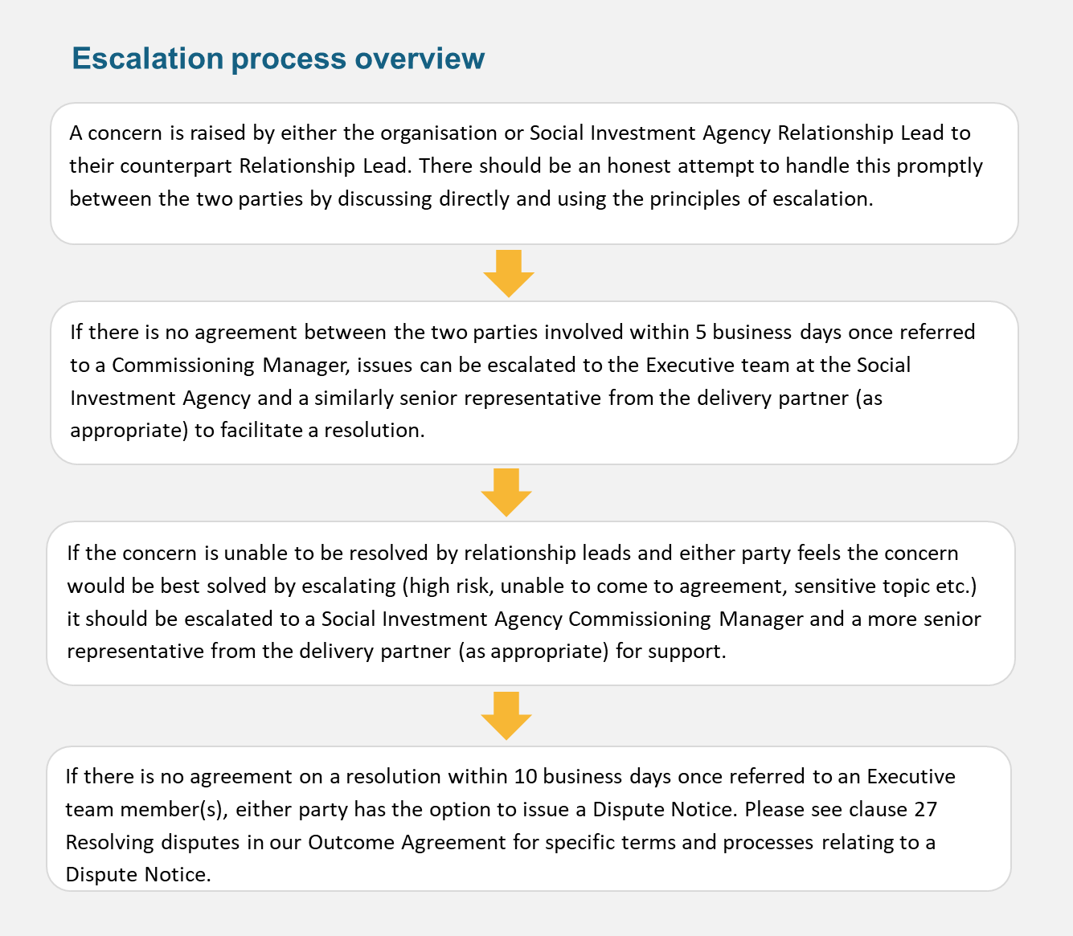

Annual reflection

Once a year we will come together for a reflection session. This is an opportunity to reflect on what is working well and areas we might need to adapt or change in terms of our relationship, or the outcome agreement. You may choose to bring in other key people from your leadership or board to these strategic reflection conversations.
The purpose of these sessions is to assess at a strategic level how the investment is progressing and ensure that the agreement, and relationship, is supporting the intended outcomes of the investment.
We will provide a summary of insights based on all our engagements (both learning loops and regular check ins) over the period of reflection, which will usually be a one-year period. This will help inform the conversation around what we have learned, what has changed and what the future looks like. If you want to propose any changes to your agreement or how we engage with and support each other, this can be raised during this reflection session.
You don’t need to wait for an annual reflection to raise any changes. Either partner can also raise any changes they think might be required to support the success of the investment at any time, either through our regular planned check-ins or learning loops, or at an unplanned check in. If this results in a change to the outcome agreement itself, each partner will ensure the appropriate considerations have been made (i.e., effects on the agreed learning and impact plan) and that the appropriate decision makers are involved.
Feedback

As part of our commitment to continuous learning and improvement, we will regularly ask you for feedback on our areas of strength and any opportunities for improvement. We are also interested in your view on other ways of working, target groups, outcome goals, and sector functioning. The different way of working under the social investment approach has aspects that are new for all of us, and we want to ensure that we are implementing the approach in ways that deliver the best outcomes. Seeking input and feedback from you is a key part of getting this right.
We will likely ask you for your feedback at key points throughout our engagements, for example after a procurement process, following the establishment phase of the agreement and at regular intervals during the learning and adapting phase of the agreement.
As part of our commitment to learning and adapting together, when we seek feedback from you and other organisations, we will summarise themes and identify learning opportunities. We are
committed to sharing these insights with you and other stakeholders, including what we’re doing to act on the feedback provided.

Section 5: Review phase
Impact Analysis
As we approach the end of the agreement period, or once the initiative has supported a sufficient number of participants (typically around 250), we will undertake an impact analysis. This analysis will follow the Learning and Impact Plan developed with you during the establishment phase, including the agreed evaluation design and, where feasible, the counterfactual group.
Throughout delivery, we will continue to learn together through regular learning loop sessions. These sessions help us understand whether any aspects of the initiative need adjustment and provide early insight into what is working. The impact analysis is a more formal point-in-time assessment that examines whether the initiative has achieved the outcomes set out in the Theory of Change.
To support this, your organisation will need to maintain consistent participant data, including clear records of eligibility criteria and referral pathways. This information helps distinguish who was eligible, who participated, and who did not – an essential component of constructing a credible comparison group. Unless otherwise agreed (for example, if an external evaluation by an academic institution is outlined in the Learning and Impact Plan), the impact analysis will be carried out by SIA analysts using rigorous, pre-specified statistical methods. Because evaluation is designed in from the start, we are better able to efficiently measure impact.
Most impact analysis approaches will include using the IDI to analyse the impact of your initiative on participants compared to a counterfactual group. In some instances, it will not be possible or appropriate to use IDI data for the evaluation, for instance there may be safety risks relating to collecting participant information to enter into the IDI. Where this is the case, we will work with you to agree an alternative evaluation approach.
Coming to the end of the agreement
12 months prior to the end of the agreement, we will start discussions about what happens at the end of the agreement. This could include a recommissioning or decommissioning process.
If the impact analysis requires further data and is indicating a highly positive change, there may be circumstances where we need to extend the existing agreement to enable the completion of a robust impact analysis.

Recommissioning
Decisions relating to re-commissioning investment will be based on a range of factors aligned to a strategic social investment approach including:
- Understanding the needs of people in communities and what investments work (based on data and evidence) to meet those needs.
- Making decisions aligned to government investment priorities and our Investment Strategy and Plan.
- Adhering to the Government Procurement Rules and Principles.
- What we have learnt through the initial investment about the people and communities you are working with.
This could mean that we re-enter into a new agreement with you for the initiative you deliver, if the impact analysis evidences positive impacts for the people you support. This could also mean that funding is reallocated within the investment portfolio in line with our agreed annual Fund investment plan.
Regardless of the approach, we will communicate our intentions as early as possible, no less than six months prior to the end of your existing agreement, wherever possible.
Decommissioning
A key part of the social investment approach is about ensuring that we are investing early in supports that meet the needs of people, informed by data and evidence. This includes ensuring that we are continuously analysing the needs of people who require support, ensuring that we are investing in initiatives that are evidenced to be meeting those needs. If this results in us needing to decommission a service we will take a principled approach, driven by:
- Data and evidence driven decision making
- Transparent process and stakeholder engagement
- Strategic transition planning.
Effective decommissioning requires a clear and objective basis for decisions and we commit to being as transparent as possible, as early as possible, with you as our partner. There are many different potential scenarios where we will need to work through a de-commissioning process including:
- You, the delivery partner, have determined you wish to end the agreement
- There is a change in government priorities or investment available
- A decision is made to transition the commissioning of specific investment to a local commissioning arrangement, to better meet the needs of people in communities
- There has been a breach of the agreement terms
- The agreement has come to a natural close and will not be renewed or will be re-commissioned.
In any event, we will work with you to ensure we take a considered and transparent approach to decommissioning to minimise any impact to the people you are supporting, your partners and wider community.
Notice periods are outlined in our outcomes agreement and we will work to the terms of the agreement. If decommissioning eventuates at the request of your organisation, you can refer to the terms and conditions set out in the agreement for guidance on what is required in this instance.
Decommissioning plan
We will work together to develop a decommissioning plan to ensure we are managing the transition minimising impact to those involved, including your organisation and staff, your partners and the people that you support. We will work with you to discuss the implications of decommissioning your initiative and document what we agree in a plan. The plan will include things such as:
- Impact assessment to understand any adverse affects for the people you are supporting, staff and/or other stakeholders so that these can be addressed through the decommissioning process
- Referrals to alternative supports, if applicable and appropriate, to ensure continuity in supports
- The transfer of any participant files, aligned to data protection and use policies
- Risk management plan and mitigations
- Decommissioning roles and responsibilities
- Outlining key timelines
Within the plan we will also outline any activities that need to be completed during the decommissioning period such as:
- The implementation of any risk mitigations
- Payment reconciliation
- Debrief to discuss lessons learned and feedback

Term | Description
Evaluation | The systematic assessment of a project, programme or policy, its design, implementation and results.
Initiative | A set of activities or actions designed to support people to achieve their goals. In the context of the SIA ‘initiative’ also covers ‘projects’, ‘programmes’, and ‘services’.
Theory of Change | A framework that outlines how and why a desired change is expected to happen due to a specific intervention.
Funding agency | The agency (e.g. SIA) that is providing funding to organisations. Also referred to as the Funding Partner.
Funded organisation | An organisation that receives funding from SIA for a specific purpose or project. Also referred to as the Delivery Partner.
Learning Loop | Learning loops are collaborative discussions where both partners sit down and discuss evidence and trends emerging from the information we have shared with each other. This activity helps us to come together to understand what is working, what isn’t, and how we pivot, if needed, to ensure we are continuously moving towards the outcomes that we are looking to achieve.
Annual Reflection | A semi-structured session between SIA and a partner organisation to assess, at a strategic level, how the investment is progressing and ensure that the agreement, and relationship, is supporting the intended outcomes of the investment.
Opportunities and risk Profile | A shared framework that will be used by SIA and our partners to understand the opportunity and risk levels of our shared investment across six areas.
Appendix A: Glossary

Appendix B: Document update log
The purpose of this log is to highlight, and support navigation to, where there have been any substantial changes to this guide.
Title | Description | Page
e.g. Update to “establishment phase” | Upon feedback an extra step has been added to the establishment phase

Appendix C: Shared opportunity & risk tool with descriptions
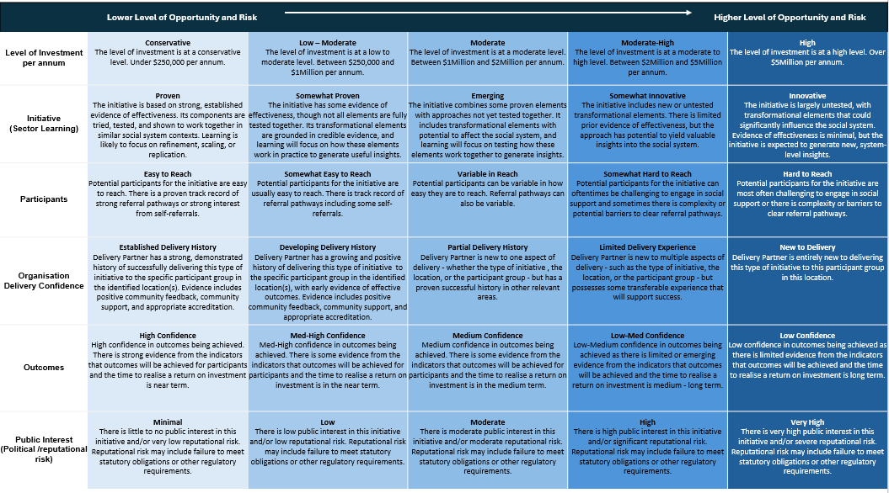

Thank you
We are on a journey towards implementing a social investment approach and appreciate some things in this new approach will take some time for us to embed and get right.
If you have any feedback on this guide or the approaches it describes, we are open to receiving this and continuously working with our partners to improve how we do things. Any feedback can be discussed with your relationship lead or provided to us at info@sia.govt.nz.

